Well organize system that will address ….

Area of preparedness and Response

Before Technical background

Common to them is BI Tool

Queries and Update Before the ETL

Table of Contents

**Process A1**

Conceptual Framework2

Overview2

**Process B4**

Description5

Objective6

Feature5

Function6

User6

**Process C1**

Software Quality Assurance2

Quality Assurance2

**Process D1**

Quality Assurance Plan2

**Source Code1**

# Process A

### 

### Conceptual Framework

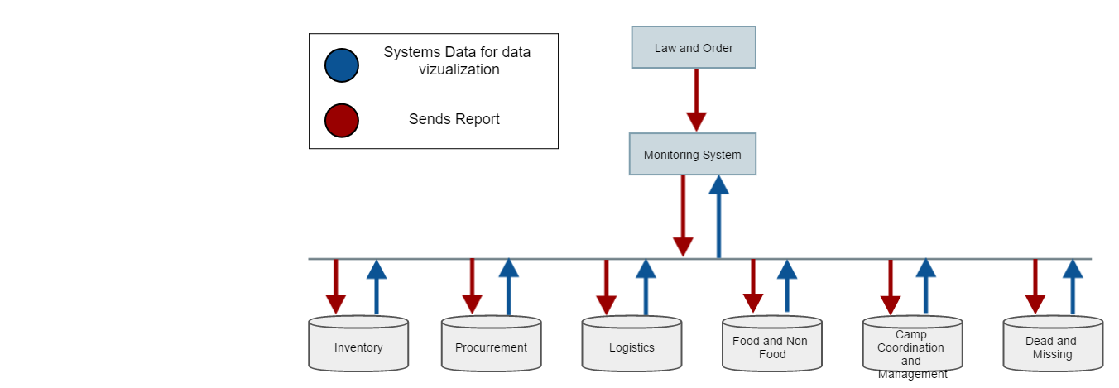

### Overview